Spicing up Circad^{tm}

Adding Simulation Capability to the Holophase^{tm} EDA Environment

Donald J. Miller
donmiller@mindspring.com
29 April, 2003

Revision 0.1 Alpha

Introduction 3
Cardamom Reference Manual 9
Parsing Rules 9
Reference Designators D, J, M, Q, S, Z (Devices with models) 9
Reference Designator W (problematic device with model) 10
Reference Designator X (subcircuits) 11
Reference Designators B, C, E, F, G, H, I, K, L, O, R, T, U, V 12
Unsupported Elements 13
Learning SPICE 13
Compatible Ports of SPICE 14
SPICE Opus 14
WinSPICE 14
Simulating Your Circuit – Step by Step 15
1) Capture your schematic in Circad^{tm} 15
2) Start Cardamom and configure all the file and directory paths. 19
3) Start up your SPICE simulator 20
4) Generate the SPICE Netlist 21
5) Simulate 21
SPICE Schematic Library 26
Appendix – Parsing Diagram 27
Software – Where to get it? 28
Cardamom 28
WinSPICE 29
SPICE Opus Lite 29

Introduction
Circad^{tm} is an extremely versatile EDA package that integrates schematic capture and printed circuit board layout capabilities under a common user interface. PCBs are routed with the same set of “tools” and methods that are used for capturing the schematic. Innovative features like a “reverse engineering” mode that allows you to layout a PCB over a bitmap backdrop of a scanned PCB image, and the ability to display an arbitrary bitmap (perhaps a picture of the expected signal) associated with a net in the design make this package an outstanding value at under $1000. Ham radio operators are able to obtain the package at a very special discount for around $300.

One feature that has been lacking in Circad^{tm}, however, is the ability to do SPICE simulations from the captured schematic. This has finally been addressed with a Windows application called “Cardamom”.

SPICE – Free but Unfriendly

SPICE was originally developed at the University of California at Berkeley in FORTRAN, and then was later re-written in C. It has a heritage of originally being run on mainframe computers, using Hollerith cards for netlist input. In parts of the Berkeley SPICE website:

http://bwrc.eecs.berkeley.edu/Classes/IcBook/SPICE/

the SPICE input netlist files are still referred to as “SPICE Decks”! The SPICE netlist, or “deck” consists of lines of ASCII text, with each line containing a single control command or information describing the connection of a single circuit component.

Today, it is possible to buy versions of SPICE that are tightly integrated with schematic capture programs, and versions of SPICE that contain schematic – input graphical interfaces of their own. Many of them suffer from one or more of the following shortcomings, however:
- Expensive
Although some vendors do provide additional added value by adding enhancements to SPICE, such as improved models and faster algorithms – the main attraction of these packages is still the ability to escape the manual netlist entry interface.

- No PCB Netlist Output
In some tools, the schematic entry function is used for simulation purposes only. In order to design a PCB, the schematic must be re-captured in another tool!

- Other Integrated Tools May Not Be Best In Class
In order to get a good simulation environment, the user might need to put up with a less than ideal schematic capture program – or perhaps the simulator and schematic sections of the package are great, but the PCB layout part of the package is hard to work with…

  - The schematic and layout environment is not Circad^{tm}!
If you are reading this document to begin with, you are probably a Circad^{tm} user. You have already demonstrated a preference for the Holophase^{tm} tool. If you wanted to use one of the other packages you would be doing so by now!

The original Berkeley software (3f5 is the latest), plus Windows and DOS ports from other sources are available for free (or almost free). A search on the Internet will expose most of them, but a few of them are mentioned here:

PSPICE (student version)
The latest available edition is v9.1. There is a schematic interface, and a limited node count.

LTSPICE
Available from the Linear Technology website (www.linear.com), this started out as a tool for simulating their switching regulators and evolved into a general purpose tool. Get it! It’s great for small, quick simulations.

SPICE Opus
Berkeley SPICE 3f5 with many memory leaks patched, plus Ga. Tech X-SPICE extensions, plus the Nutmeg post-processing language. The “lite” version is missing the optimization extensions present in the commercial version, but the simulator engine is the same. The free version has a generous 300 node capacity.

WinSPICE
This appears to also be a 3f5 port with memory leaks fixed, plus Nutmeg. There is no hard-coded node limitation.

Of the four SPICE versions listed above, PSPICE is probably the most famous and the most used in universities. LTSPICE is a relative newcomer and is the handiest for small investigative simulations. SPICE Opus and WinSPICE are both netlist-input versions that will turn out to be the most useful with Circad^{tm} because of the Nutmeg support.

Interface Circad^{tm} to SPICE: It can’t be done!

It’s true that the netlist that Circad^{tm} writes does not have sufficient field space to handle all of the possible SPICE constructs. Imagine, for example, an AC current source with a 45 degree phase offset that consists of a 10 kilohertz carrier modulated by a 1 kilohertz tone <whew>:

ISRC 23 21 AC 0.333 45.0 SFFM(0 1 10K 5 1K)

The “Pattern” field is our actual schematic library symbol name, so it is unavailable. The Ref ID will be “ISRC”. The node connections (23 and 21) are handled by the netlist. We probably want to keep the PCB footprint field free for it’s intended use, so that just leaves two fields: “value” and “modifier” to eat up the rest: “AC 0.333 45.0 SFFM(0 1 10K 5 1K)”. I don’t think so…

In addition, it would be nice if we could embed simulator commands directly into our schematic. If we are repetitively doing the same simulation on a circuit that we are constantly modifying, do we really want to re-type all those instructions into the SPICE command window each time?

Outside of the Box, or err… Netlist!

The actual Circad^{tm} schematic file contains any text strings that we place on the schematic, so maybe we can grab additional component data and commands directly from the schematic file! We would need to somehow “tie” the additional parameter strings to the associated component, and also somehow make sure that command strings were executed in the proper order.

Special Embedded Strings in Circad^{tm} Schematics for SPICE

A text string of the form:

.ADDP REFDES any-text-at-all-la-di-da-di-da-fififofum

is interpreted by the Cardamom SPICE bridge software as being additional parameter data for the component “REFDES”. The string “REFDES” must match the reference designator of the associated component exactly and is case sensitive. The string “any-text-at-all-la-di-da-di-da-fififofum” is appended directly to the description of the related component after a delimiting space character. The string “.ADDP” must be all caps, and the leading “.” (period) is important.

There is some flexibility in the way .ADDP statements are used. Consider a capacitor, C1 of 10uF with an initial voltage condition of 3V. This component can be described two ways on the schematic:

- Refdes field: C1
”Value” field: <Empty>
text on schematic: .ADDP C1 10uF IC=3V

-----0r-----

- Refdes field: C1
”Value” field: 10uF
text on schematic: .ADDP C1 IC=3V

Care must be exercised, however. Later in this document, the parsing rules are given, and it will be clear that if a component references a model or a subcircuit, the name of the model or subcircuit MUST be in the value field.

A text string of the form:

.CONTROL n text-line-which-means-something-to-nutmeg

is interpreted by the software as a control command. The “n” is a numerical ordinal value. That is, the order that the command shall be executed. Successive control statements are numbered n= 1,2,3,4,… The following text “text-line-which-means-something-to-nutmeg” is something which is meaningful to the Nutmeg command processor. The string “.COMMAND” must be all caps, and the leading “.” (period) is important. The Nutmeg command string is all lower case, EXCEPT for node references, which must match exactly the schematic node name.

Consider the following statements:

.CONTROL 1 ac oct 10 1 30k
.CONTROL 2 plot v(OUT)
.CONTROL 3 tran 10us 100ms 98ms
.CONTROL 4 plot db(v(OUT))

These statements need not be placed together on the schematic. The ordinal inside the statement always determines the order of execution. The bottom of the resultant SPICE netlist will look like this:

.control
ac oct 10 1 30k
plot v(20)
tran 10us 100ms 98ms
plot db(v(20))
.endc

…and this is what happens:

- A small signal AC analysis is performed with 10 points per octave from 1 Hz to 30 KHz.
- The voltage at node 20 is plotted. Since there is no guarantee that node names on a schematic will be legal SPICE node names, Cardamom re-numbers the nodes.
- A transient analysis is done with a minimum step size of 10us from t=0 to t= 100ms. The data from 98ms to 100ms is retained.
- The voltage at node 20 (= node “OUT”) is plotted in db referenced to 1 volt.

Other Control Strings in Cardamom

The following SPICE “dot” commands, if found in the schematic, will be passed on to the SPICE netlist. The commands must be all caps, although the arguments case-sensitivity will depend on the SPICE program:

.INCLUDE
.PARAM
.OPTIONS

Cardamom Reference Manual

Parsing Rules

Reference Designators D, J, M, Q, S, Z (Devices with models)

Diodes(D), JFETs(J), MOSFETs(M), BJTs(Q), Switch(S), MESFETs(Z)

These components are all described by models. The referenced model “modelname” must be placed in the value field. There must be a file in the model directory that the user has pointed Cardamom to with a file named modelname.txt. If the SPICE description requires additional information after the model, it should be placed in a .ADDP statement.

Examples:
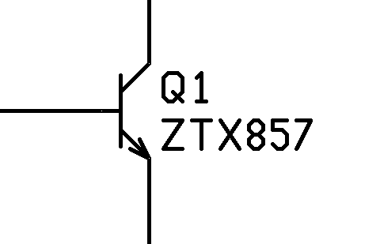 | Reference Designator Field = “Q1”  Value Field = “ZTX857”  Resultant SPICE Netlist Lines:  .INCLUDE C:\Models\ZTX857.TXT  Q1 4 8 2 ZTX857
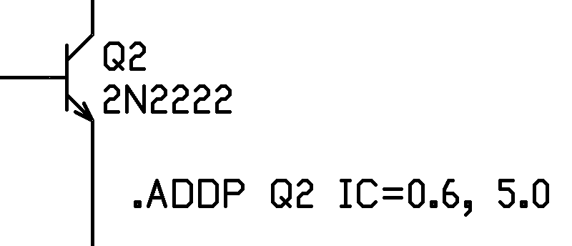 | Reference Designator Field = “Q2”  Value Field = “2N2222”  Additional text on schematic:  “.ADDP Q2 IC=0.6, 5.0”  Resultant SPICE Netlist Lines:  .INCLUDE C:\Models\2N2222.TXT  Q2 5 9 2 2N2222 IC=0.6, 5.0

In the examples above, the node numbers are representative only. They are determined by how the device is connected in the schematic. The exact path of the C:\Models may be different in a particular installation.

Reference Designator W (problematic device with model)

Voltage Controlled Switch (W)

This element takes a model and the name of a voltage source as arguments. Unfortunately, the name of the voltage source comes before the name of the model in the SPICE line. In all the other elements requiring a model or subcircuit name, the model or subcircuit identifier comes directly after the node number list.

The parser in Cardamom does not provide for the special case behavior of this likely to be infrequently used model.

There is, however, a (untested) workaround:

- Manually place an .INCLUDE statement on your schematic that points to the model file of your switch.
- Place your switch component (W) in the schematic and wire it normally.
- Place the associated voltage source name in the “value” field of the switch component.
- Place an .ADDP statement nearby with the model name plus any other needed arguments for the switch.

The voltage-controlled switch reference designator is treated as a non-model type by Cardamom, so the value field does not cause an .INCLUDE statement to appear in the netlist to load the switch model. In the workaround above, the model is .INCLUDE’d in the SPICE netlist explicitly via a schematic command, and then referenced by the parsed name from the .ADDP statement.

Reference Designator X (subcircuits)

Subcircuits (X)

This case is very similar to the case where the component uses a model. The only difference is that a SPICE subcircuit file is referenced instead.

When using SPICE “models” you obtain from vendors or anyone else, you must examine them carefully to see if they really are model files. Quite often, they are really subcircuits. The first non-comment line of the file will be either .MODEL or .SUBCKT

In practice, the main differences between using devices that reference subcircuits compared to those that use models are:

- The reference designator must indicate that the device is modeled by a subcircuit. If you have a transistor, say Q39 in your circuit and the description is a subcircuit, then you better make the first letter of the reference designator “X”. You will probably prefer to re-label the device “XQ39” instead of “X39”, but SPICE won’t care either way.
- The subcircuit file “subcircuit.txt” must be placed in the path used by your Cardamom installation for subcircuits instead of the path used for models.
- Beware of the presence of quartz crystals or ceramic resonators in your schematic. The usual reference designator of X? is used for subcircuits. Usually, these type of components are modeled by subcircuits anyway, though…

Always put the subcircuit name in the “value” field of the component. If it is placed in an .ADDP statement, the .INCLUDE directive to load the subcircuit will not be placed on the SPICE netlist.

If you use the same block of circuitry in a lot of your designs, you can do a few slight edits to the SPICE netlist of that block, and create your own subcircuit file for use in later simulations.

Reference Designators B, C, E, F, G, H, I, K, L, O, R, T, U, V

Non-Linear Dependant Sources (B)
Capacitors(C)
Linear Voltage-Controlled Voltage Sources (E)
Linear Current-Controlled Current Sources (F)
Linear Voltage-Controlled Current Sources (G)
Linear Current-Controlled Voltage Sources (H)
Independent Current Source (I)
Coupled Inductors (K)
Inductors (L)
Lossy Transmission Line (O)
Resistor (R)
Lossless Transmission Line (T)
Uniform Distributed RC Line (U)
Independent Voltage Source (V)

These elements are parsed simply. The SPICE nodelist line will consist of the contents of the Refdes field, followed by the node list, followed by the contents of the “value” field, followed by any additional information stripped off a mating .ADDP text string in the schematic.

Unsupported Elements

Semiconductor resistors and semiconductor capacitors are not directly supported by Cardamom. However, they can likely be included by using a workaround to get Cardamom to place the required .INCLUDE directives into the netlist. See the documentation for the voltage-controlled switch model (W). The same technique should work for semiconductor R’s and C’s.

Learning SPICE

The purpose of this document is to describe the operation of the Cardamom SPICE bridge for the Circad^{tm} schematic capture program. A detailed treatise on SPICE is beyond the scope of this document. If you are not familiar with SPICE, you should pursue some other resources. You do not need to be an expert on SPICE to read this manual or use Cardamom, but a little familiarity with Berkeley SPICE will clear up a lot of the fog. A list of resources follows:

On-Line HTML SPICE3 Manual
http://newton.ex.ac.uk/teaching/CDHW/Electronics2/userguide/

PDF version of SPICE3 Manual
http://fides.fe.uni-lj.si/SPICE/download/berkeley.zip

Overview of SPICE
http://www.seas.upenn.edu/~jan/SPICE/SPICE.overview.html

Nutmeg post-processor
http://bwrc.eecs.berkeley.edu/Classes/IcBook/SPICE/MANUALS/nutmeg.html

Compatible Ports of SPICE

Two free versions of SPICE have been found to work quite well with the Cardamom SPICE bridge software: SPICE Opus and WinSPICE.

SPICE Opus
SPICE “OPUS” stands for “SPICE with integrated OPtimization Utilities”. It is an integration of Berkeley SPICE 3f5, Georgia Tech XSPICE, Nutmeg, plus some added optimization utilities. The free version, “SPICE Opus Lite” does not contain the optimization utilities and is limited to circuits of less than 300 nodes. In practice, 300 nodes are fairly generous for most uses.

SPICE Opus quirks, irregularities, and notes
  - Plot windows do not “like” being closed before the data plotting is complete.
  - The “m” parameter used in diode models must be changed to “mj”.
  - Does NOT sense when SPICE netlist has changed, so a “source filename” command must be done after every circuit change.

WinSPICE
This port contains Berkeley SPICE 3f5 and Nutmeg, and has no hard-coded node limit. After the source netlist is loaded the first time, WinSPICE seems to detect when the file changes and automatically re-starts the simulation. This makes the Circad^{tm}/SPICE integration that much “tighter”!

WinSPICE quirks, irregularities, and notes
  - No irregularities known.
  - Senses changes in input SPICE netlist. This is pretty cool. After the first time you type “source filename”, you don’t need to do it again in that session. After the schematic is saved and the netlist exported from Circad^{tm}, pressing the “Process” button in Cardamom sets everything else in action.

Simulating Your Circuit – Step by Step

1) Capture your schematic in Circad^{tm}
While doing so, remember:
-> If a component has a numerical value (like a resistor or capacitor), it goes into the “value” field as normal. Note the SPICE convention for units! Use 1MEG for a 1 megohm resistor, for example. A 1 milliohm resistor is 1M !
-> If a component references a model, put the model name in the “value” field. Make sure that the model (“yourmodel”) is in a file named “yourmodel.txt” in the directory with the rest of your models. If you are placing a subcircuit on your schematic, put the subcircuit name (“yoursubcircuit”) in the “value” field, and put the subcircuit description in a file called “yoursubckt.txt” in the directory with the rest of your subcircuits.
Most SPICE simulators choke on pathnames that have spaces in them, so to be safe, you might put your models and subcircuits in a place where the path is really simple – like C:\models and C:\subckts.
Sometimes vendors put a number of models or subcircuits in the same text file. You will need to break them up into individual files with a text editor when using Cardamom. Also it is VERY IMPORTANT to make sure that the model inside the text file has the same name as referenced. It is very typical for a vendor to have a file called 2N2222.mod, where internally the device is referred to as Q_2N2222. You will need to edit this circuit so that the internal name is 2N2222, and save it to a file as 2N2222.txt. The referenced model in the schematic will be value = 2N2222. You see? They just all need to match.
Know for sure if the vendor has provided you a model or subcircuit. Some “models” are really subcircuits. It will make a difference unless you store your models and subcircuits in the same directory (but that will get messy!).
-> If the required SPICE line for a component requires more data than provided in the “value” field, place an .ADDP statement on the schematic referencing the reference designator of the component to be modified. The “.ADDP” prefix stands for “added parameters”.
-> Add the necessary specialized SPICE symbols for simulation. In most cases, this will be one or more independent sources (power supplies and input signal).
-> Add .CONTROL statements to control the simulation. This will determine what type of simulation will be done, and what data will be plotted.
-> If the .ADDP and .CONTROL statements confuse you, try reviewing the section on page 6 “Special Embedded Strings in Circad^{tm} for SPICE”. If that doesn’t completely clear things up, hopefully some of the examples to follow will help.
Example Schematic:
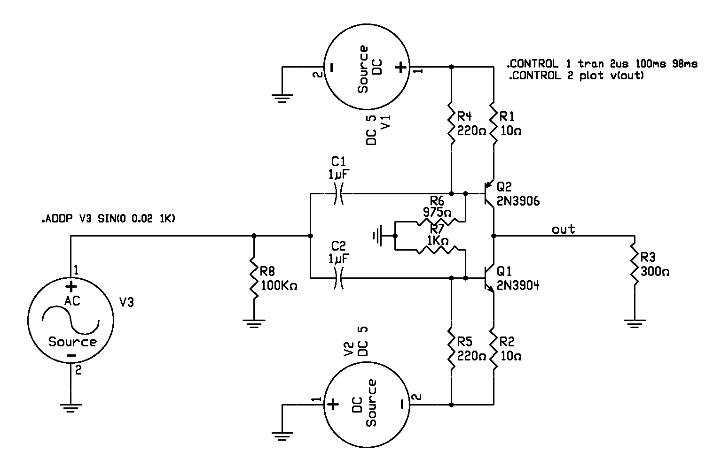
In this example, all the resistors and capacitors have their values placed in the “value” field of the respective components, and the transistors have their model names “2N3906” and “2N3904” in their “value” fields.
The DC sources, V1 and V2 each have the string “DC 5” placed in their “value” fields. Nothing fancy here.
The input source, V3, has NOTHING in its “value” field. There is an .ADDP command on the schematic associated with this component, however. Note:

.ADDP V3 SIN(0 0.02 1K)

When the SPICE netlist gets built, everything after the “V3” in this string will be appended to the description of V3. The schematic netlist description of most components will contribute the following to the SPICE netlist line:

RefDes N1 N2 N3 … “value”

Where “Refdes” is the component reference designator (C1, R56, V3, or something), the N1, N2, etc… numbers are nodes or nets, and the string from the component “value” field is copied verbatim to the line after the node numbers. So, in the case if our V3 source, only the following comes from the schematic netlist since “value” contains nothing:

V3 N1 N2

Where N1 and N2 are the names of the nets V3 is attached to.

But wait, there’s more! Cardamom parses the actual schematic file looking for those .ADDP strings. It matches them with the schematic netlist components, and adds more data to the SPICE line. In the case above, the string “SIN(0 0.02 1K)” is parsed from the .ADDP statement and appended to the SPICE component line. So V3 is now described as:

V3 N1 N2 SIN(0 0.02 1K)
This is an AC sine wave source with a 0V DC offset, amplitude of 0.02V, and a frequency of 1 KHz.

Our schematic also has some simulator commands embedded in it:

.CONTROL 1 tran 2us 100ms 98ms
.CONTROL 2 plot v(out)

.CONTROL statements must begin with .CONTROL (all uppercase and the leading period is important) and have an integer ordinal immediately following the .CONTROL clause. These control statements are executed in the order specified (.CONTROL 1 yadayada, then .CONTROL 2 yayaya, etc…). The NUTMEG commands inside must generally be all lower case. The exception to this is the way node names are expressed. If you want to plot the voltage an a node named HARRY, then you would write .CONTROL 3 plot v(HARRY)

In the schematic that we are working on, the output voltage that we are plotting is named “out” in all lower case, so the .CONTROL statement references that node as “out” in all lower case. Please note, however, that Circad^{tm} will rename the net-name to “OUT” (all caps) after the schematic has been saved and reloaded. So, a schematic that simulated fine yesterday might not work OK today because the node names do not match the plot() statements. For this reason, it is a good idea to ALWAYS name your node names in all caps. This way, the names will not change on a save and load.
The node referenced in brackets by v( ) must match the name of the schematic net in a case sensitive manner.
! This case sensitivity of net names is guaranteed to bite you. It has already got me a number of times.

In our example above, the first control statement specifies a transient simulation with a 2us minimum time step from 0 to 100 milliseconds. The data from 98 milliseconds to 100 milliseconds is saved for analysis.

The second control statement plots the voltage at the node named “out”.

2) Start Cardamom and configure all the file and directory paths.

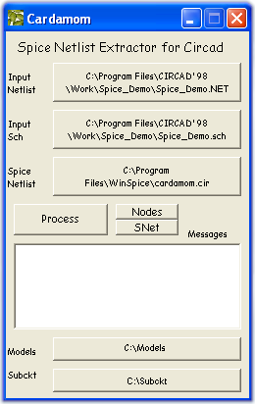
FIRST: If you haven’t saved your schematic and generated a netlist, do so now!

Click on the “Input Netlist” button and use the resulting file dialog box to browse to your Circad^{tm} netlist file.

Click on the “Input Schematic” button and use the resulting dialog box to browse to your Circad^{tm} schematic file.

Click on the “SPICE Netlist” button and use the resulting dialog box to select the filename for the SPICE netlist output. Usually it is best to place this in the same directory as your SPICE program so you do not need to type the whole path in SPICE. In the example to follow, it will be assumed that the SPICE netlist is “Cardamom.cir”.

Click the “Models” button and use the resulting directory dialog to point Cardamom to the place where you store your models.

Click the “Subckt” button and use the resulting directory dialog to point Cardamom to the place where you store your subcircuits.
Some SPICE simulators do not like to find things like “spaces” in the .INCLUDE file paths. This issue was found with SPICE Opus but not verified with WinSPICE yet. Some directories, like “…\Program Files\...” might cause problems. You might want to make your paths for your models and subcircuits kind of simple to keep from running into these types of issues. Think “Would DOS understand this path?”

WinSPICE apparently will allow paths with spaces if the path is enclosed in quotes. This has not been tested with SPICE Opus. If placing the .INCLUDE file paths in quotes eliminates the problem with paths that have spaces in them, a later version of Cardamom will implement this fix (provided that it doesn’t cause issues when paths do not have spaces).

3) Start up your SPICE simulator
Let’s Run WinSPICE!
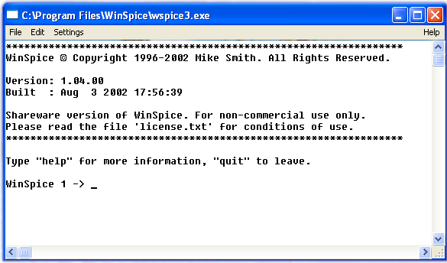
If all is well, you should get a window that looks something like the one above.

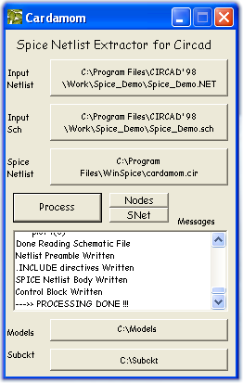
4) Generate the SPICE Netlist
Push the “Process” button. Text will appear in the message box. If you scroll to the bottom of the box, you should see messages very similar to what is pictured here.
-> The message box was built in mainly for debugging purposes, and may disappear in a future revision of Cardamom.
5) Simulate
In the WinSPICE command window, type:
source cardamom.cir
After you do that, your monitor will probably look very similar to the one on the next page.
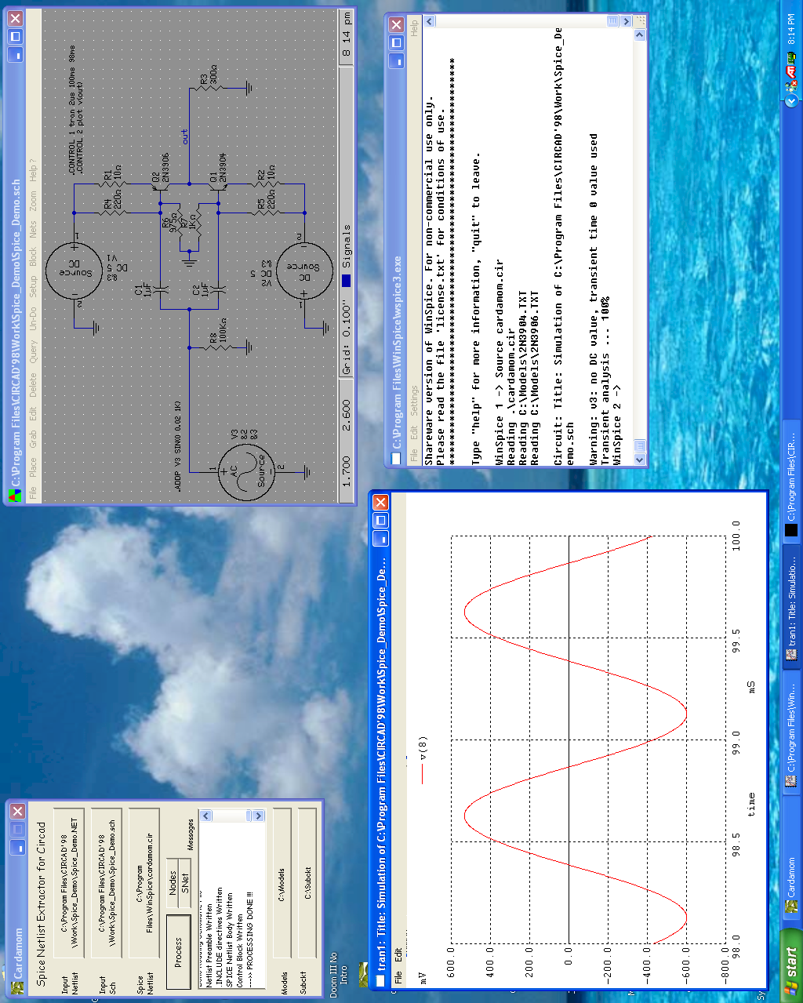

Remember those instructions to plot v(out) from t=98ms to 100ms? Well the data is sitting right in front of you, in an attractive plot.
But wait… the plot says that it plotted v(8). Whatsupwidat?
Cardamom does not assume that all the node names you have on your schematic are all legal SPICE node names. In fact, it assumes that they will not be legal, and just merrily renumbers them all. A node translation table is built, and any commands referencing nets (nodes) in your .CONTROL statements are adjusted to point to the new names.

At this point, you can edit the schematic, save it, run a new netlist, and push the “Process” button again. WinSPICE seems to realize automatically that the SPICE netlist has been revised, and it simulates again automatically. If this does not occur with your version of WinSPICE, you just need to type the “source cardamom” command again.
So, if you want to plot data for a different node in your circuit, you can just edit the .CONTROL statement to plot that node, or you can add more .CONTROL statements. You can plot multiple voltages on a plot, or generate more than one plot in a given run. (Just remember that every time you modify the schematic, you must 1)Save it, 2)Export the netlist, and 3)Push Cardamom’s “Process” button.)
…but you don’t need to re-simulate to plot another node. WinSPICE is sitting there, just waiting for you to type some Nutmeg commands – but it will want the revised node numbers. Yikes.
Well, you see that button marked “Nodes” in the Cardamom window? Push it and get access to the node translation table. See all the nets you didn’t explicitly name that look like $0003, $0005, etc…? You still don’t know what they are! It is a good idea to explicitly name any net on the schematic you might have an interest in analyzing later so that you can find it easily in this table. If you find yourself querying a net in Circad^{tm} to find the name for a plot v( ) statement, stop and name that net!

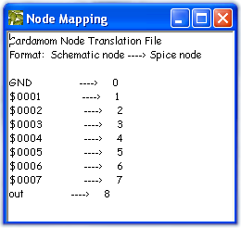

Node Map made visible by the “Nodes” button

If you want to see the SPICE netlist that Cardamom has generated, push the “SNet” button.

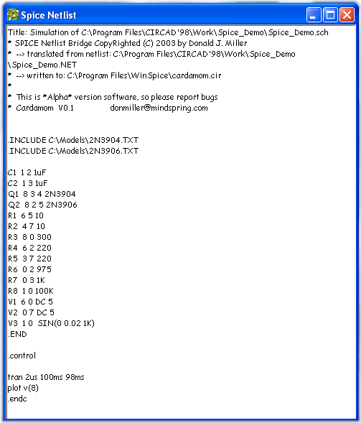

Pushing the “SNet” button displays the actual SPICE Netlist

SPICE Schematic Library

Cardamom comes with a library of SPICE components. This library is not guaranteed to be complete, but will allow the user to have enough symbols to simulate right away.

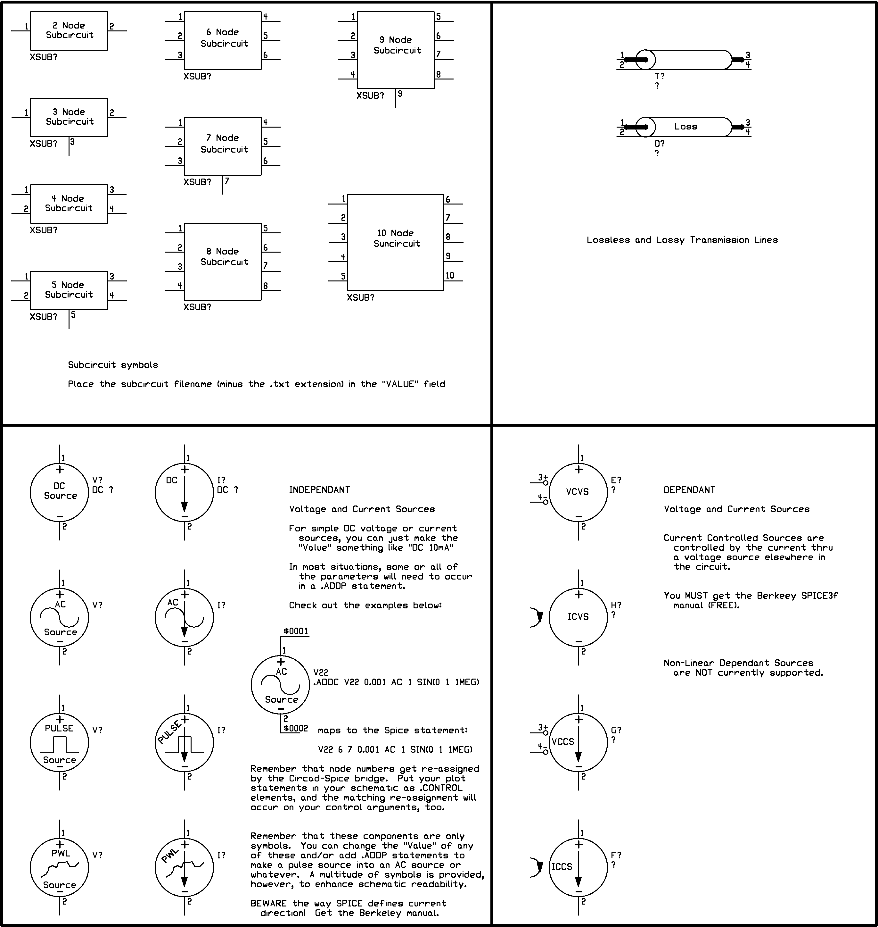

Appendix – Parsing Diagram

Software – Where to get it?

Cardamom
The alpha version of Cardamom is available by http download at:

http://www.mindspring.com/~donmiller/cardamom/

The alpha version of software is offered on a shareware basis. There are no restrictive circuit size limitations, and the program is offered “as-is” without warrantees of any kind. If you find the program useful, a registration fee of $35 is suggested.

Registration gives you the following benefits:

- Free upgrade to version 1.0
When Cardamom comes out of Alpha, the “shareware” versions of future editions will have circuit size limitations, and registration will be necessary to remove them. Note that if my work on the alpha version turns out to be perfect ☺, this will not be an issue, since version 1.0 will be essentially the same as the alpha software. How often are alpha versions perfect ??
- You encourage me to develop the next version with enhancements to be determined!
- Support by email.
---→ For Cardamom, not for SPICE!
I will try to answer email questions from non-supporting users on a time-available basis, and bug reports are welcome from everybody. I will try to keep a bug log on my website, so please check there before you report. I don’t need a gazillion emails about a bug that I have known about for a while.

To register your copy of the alpha version of Cardamom, send a check for $35 to:

Donald J. Miller
4316 Perth Trace
Roswell, Ga. 30075

Include the following information:

Your name
Your address
Your email address
Any comments about Cardamom

WinSPICE

Go to www.WinSPICE.Com and get it.

SPICE Opus Lite

This is available at http://www.fe.uni-lj.si/SPICE/welcome.html . This was actually the first package I used while developing Cardamom. It works well, but the way WinSPICE automatically re-simulates when the SPICE netlist has been altered by another program is just way too slick.

Circad^{tm}
Information about Circad^{tm} is available at http://www.holophase.com

If you have an amateur radio license, you’ll want to purchase your copy from Jay Craswell, W0VNE for a very attractive discount. Information on the discounted amateur radio operator packages is available at http://www.dover.netfirms.com

